|  |
| --- |
| Covid Quiz Master |
|  |
| 1st April 2022  BY: NIDHI CHAWLA |



Table of Contents

Introduction 3

System Development Life Cycle 4

Requirement Analysis 5

5Ws and H Framework 5

SWOT Analysis 5

Behavioral Diagram 7

Use Case Diagram 7

Requirements/Solution Design 8

High-Level Requirements 8

Low-Level Requirements 8

Test Plan and Results 10

# Introduction

|  |
| --- |
| Covid pandemic has increased over the world drastically and it is necessary to check people’s awareness around this virus. We have designed a quiz master that will help in assessment of knowledge among people and help governments formulate public policies accordingly. People are encouraged to take quiz as there is a free prize or cash voucher on answering all the questions correctly. This tool will not only help in testing people’s awareness but also encourage them to gain more knowledge around this subject. |

# System Development Life Cycle

|  |
| --- |
| System development life cycle is the standard process adopted for creating and maintaining an information system. It has got six stages as follows.  For our project, all six stages were performed.   * First, we had analyzed the need of society. * Then created solution design and requirements * Developed solution using C language * Created test cases using requirements and tested the developed system * Deployed solution on Git hub * Performed all the necessary documentation * Evaluation of solution in the market and gathering feedback to improve it further |

# Requirement Analysis

This section details the initial requirement analysis findings. We will use 5Ws framework and SWOT analysis technique to assess the business need and requirements.

## 5Ws and H Framework

* Who are we trying to help?

Common public and governments.

* What is your Product Vision?

To help assess awareness of covid among people and encourage them to gain more knowledge with motivation to gain prizes on winning the quiz.

* Where should we start?

Government portals and government banks are the best places. Put a QR code to get the application.

* Why will we succeed?

It is a unique concept with no offerings like this in the market currently.

* When should we launch?

The launch should be done immediately as it is necessary to assess public awareness to avoid the spread of disease.

* How will we do it?

We will use C language to develop the quiz system.

## SWOT Analysis

* Strength - Unique concept and price money will attract users
* Weakness - Static set of questions can make users win the game easily. We need to randomize questions in upcoming implementations.
* Opportunity - Covid pandemic is going on, so this product will help users and this can be scaled in other situations as well where user education is necessary.
* Threats - If the product works well, it can be implemented by other users, so we need to bring in enhancements frequently to distinguish the product and make it hard to replicate easily.

# Behavioral Diagram

## Use Case Diagram

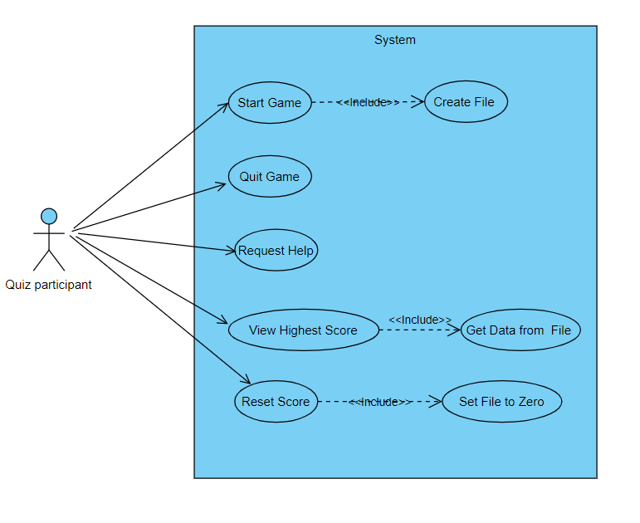

# Requirements/Solution Design

This section details the requirements and solutions created for our system.

## High-Level Requirements

* Show a list of menu options to users to start the game, quit the game, reset scores or ask for help.
* Allow the user to enter the name on starting game and display rules to the user.
* Allow user to play warm-up round and disqualify user from playing the main round if the score is less than 50%.
* Allow the user to play the main round and save the number of correct answers.
* End game on giving any single incorrect answer and show the final winning amount.

## Low-Level Requirements

* Show a list of menu options to users to start the game, quit the game, reset scores or ask for help.
* On launch of software following menu options should be displayed to the user.

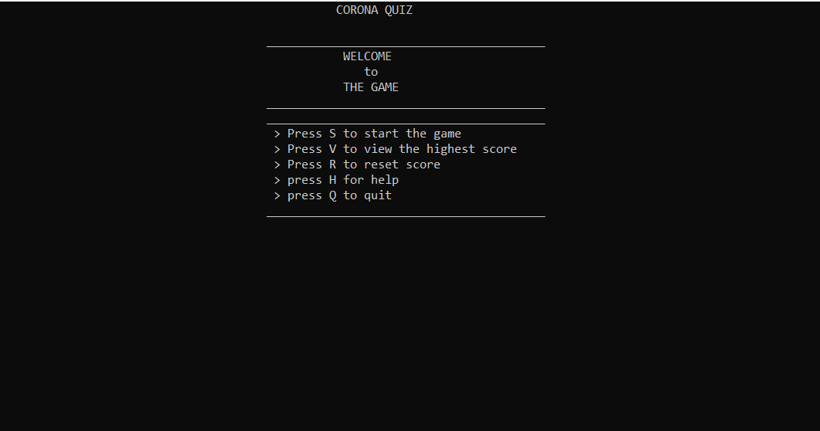

* Allow user to enter the name on starting game and display rules to the user.
* At the start of the game, a screen should be displayed to allow users to enter their name.
* Once a user enters the name, their details and score should be stored in a file.
* A screen with below-mentioned rules should be displayed to the user.
* There should be two rounds in this Quiz Game: Warm-up round and Challenge round.
* In warm-up round, user should be asked a total of 3 questions to test general knowledge.
* User is eligible to play the challenge round if they give at least two right answers. Otherwise, user can't proceed further to the Challenge Round
* User will be given four options and you have to press A, B, C or D for the right option.
* All these rules should be displayed on the screen to the user.
* Allow user to play warm-up round and disqualify user from playing the challenge round if the score is less than 50%.
* A total of three warm-up questions should be displayed to the user.
* If user gets two questions wrong, they should be displayed an error message and should not be allowed to proceed to the challenge round.
* If user gets one or zero question wrong, they should be displayed a success message and taken to challenge round.
* Allow user to play the main round and save the number of correct answers.
* In the challenge round, a total of 10 questions will be there.
* For every correct answer user will get INR 1000/-.
* End game on giving any single incorrect answer and show the final winning amount.
* If user gives an incorrect answer, the game should exit and the number of correct answers multiplied by INR 1000/- amount should be displayed to the user.

# Test Plan and Results

This section details out test plan and results achieved on testing the software.

|  |  |  |  |
| --- | --- | --- | --- |
| **Test Case #** | **Test Case** | **Test Steps** | **Result** |
| 1 | Verify software is launching correctly | * Go to .exe file and double click on it | Pass |
| 2 | Verify user is able to quit the game | * Launch software * Press ‘Q’ key | Pass |
| 3 | Verify user is able to request for help | * Launch software * Press ‘H’ key | Pass |
| 4 | Verify user is able to view the highest score | * Launch software * Press ‘V’ key | Pass |
| 5 | Verify user is able to reset score | * Launch software * Press ‘R’ key | Pass |
| 6 | Verify user is able to start the game | * Launch software * Press ‘S’ key | Pass |
| 7 | Verify user is able to enter the name | * Launch software * Press ‘S’ key   Type name and press enter key | Pass |
| 8 | Verify user is not able to go to challenge round on failing in warm-up round | * Launch software * Press ‘S’ key * Type name and press enter key * Enter answer for first and second questions incorrect | Pass |
| 9 | Verify user is able to go to challenge round on passing warm-up round | * Launch software * Press ‘S’ key * Type name and press enter key * Enter answer for first and second questions correct * Challenge round appears | Pass |
| 10 | Verify game is ending on an incorrect answer and prize amount is reflected correctly | * Launch software * Press ‘S’ key * Type name and press enter key * Enter answer for first and second questions correct * Challenge round appears * Answer first 5 questions correct and 6th one incorrect * Game ends and INR 5000/- prize value appears on the final screen | Pass |
| 11 | Verify game is ending on an incorrect answer and prize amount is reflected correctly | * Launch software * Press ‘S’ key * Type name and press enter key * Enter first and second questions correct * Challenge round appears * Answer all 10 questions correct * Game finishes automatically and INR 10,000/- prize value appears on the final screen | Pass |